**Core Report**

**Sec #3, Core #1 High –** Concrete Deck, 2” ISO, Ballasted EPDM - Wet

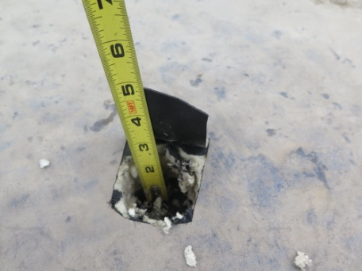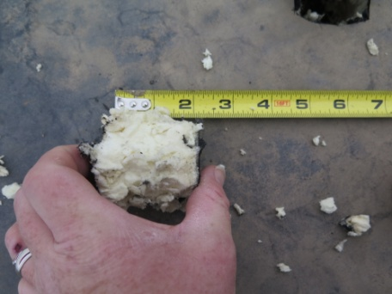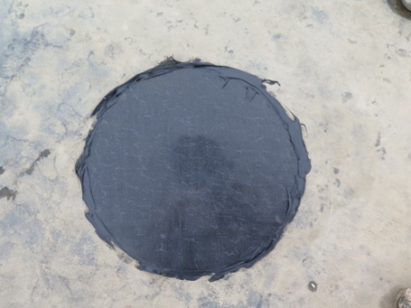

**Sec #3, Core #2 Low –** Concrete Deck, 2” ISO, Ballasted EPDM - Wet

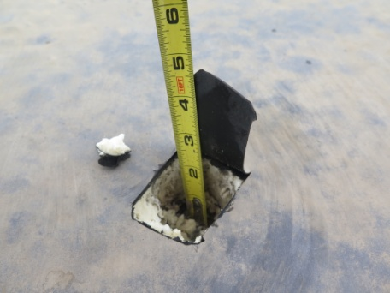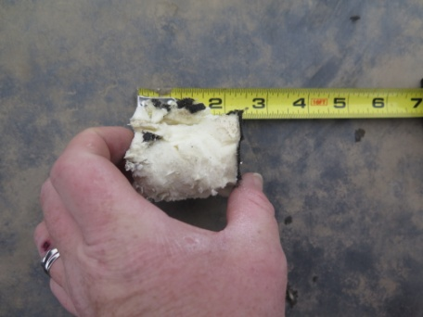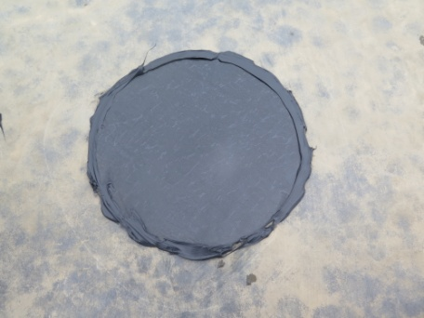

**Sec #11, Core #1 High –** Concrete Deck, 2” ISO, Ballasted EPDM - Dry

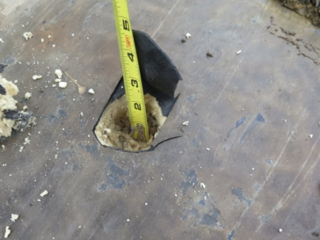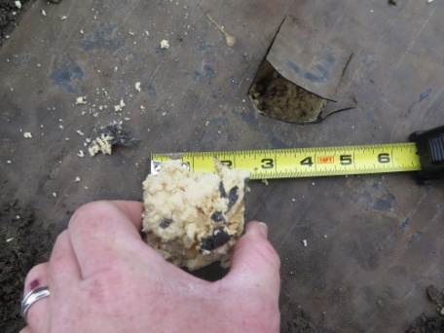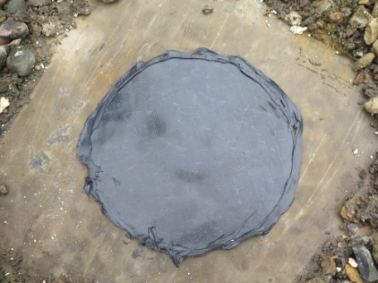

**Sec #11, Core #2 Low –** Concrete Deck, 2” ISO, Ballasted EPDM – Dry

